Atmel AVR 2004 Design Contest Project No: A3810

AVCX – Color TFT LCD Controller

There is an abundance of different kinds of small color LCD displays available today, which is probably the result of popularization of cellular phones and PDAs. Some of those displays may be purchased from the surplus merchants at incredibly low prices. Quite often, such displays are designed with the particular custom controlling chip in mind, which is usually not available for purchase. The generic color TFT LCD controller chips are not always available and often cannot be set-up to drive the particular display.

This project shows how to use an AVR micro controller chip to generate all the signals needed to control a color TFT LCD display. The Figure 1 shows the block diagram of the controller, which drives the ACX705AKM 512 colors 240x160 TFT LCD display by Sony. The device has been called “AVCX” (AVR + ACX705AKM ).

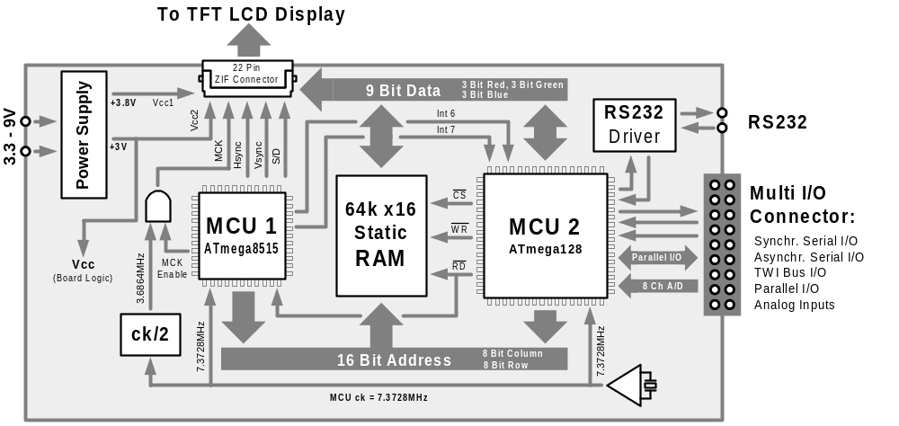Figure 1 Block Diagram

AVCX uses two AVR chips to control the LCD: MCU1 (Atmega8515) and MCU2 (Atmega128). Both micro controllers share the Static RAM, which is used as the Video RAM.
MCU1 pick-ups the color pixel data from the Static RAM and controls the LCD by generating the following "digital CRT" video signals:
- MCK (dot clock)
- Hsync (horizontal synchronization)
- Vsync (vertical synchronization)
- 9 bit RGB (3 bit Red + 3 bit Green + 3 bit Blue)
- S/D (shutdown)
With each pulse of the dot clock, MCU1 addresses Static RAM with the new 16-bit address, which is used to retrieve the 9 bit RGB data. It is worth to mention, that the frequency of the MCU1 clock (7.3728 MHz), is only two times higher than the frequency of the LCD dot clock (3.6864 MHz). Such efficiency is one of the many qualities of the Atmel AVR architecture.

MCU2 interprets graphic commands (received through RS232, or any other interfaces) and stores the resulting pixels in the shared Static RAM, where they are picked-up one by one by MCU1 and sent to the LCD as described above. The ATmega128 has been chosen as MCU2, because of a multitude of different interfaces and a big flash memory, which is used to store fonts and bitmaps.

The AVCX may be used as an “intelligent” LCD controller or as a stand alone device as well. There is plenty of flash memory left in ATmega128 to incorporate additional graphic instructions, or to customize the software for particular tasks. Possible applications include automotive, avionics, nautical, industrial control, hobby, etc.

